1. Demonstrate Swagger Installation to Web API
Swagger is a tool used to test and document Web APIs. It provides a browser page where all API methods are listed and can be tested without using any other software.
Steps:
1. Install the NuGet package 'Swashbuckle.AspNetCore'.
2. Add AddSwaggerGen() in Program.cs/Startup.cs to generate API documentation.
3. Add UseSwagger() and UseSwaggerUI() to enable the Swagger page.
4. Run the project and open the Swagger URL. All API endpoints will be displayed.

2. What is ProducesResponseType?
ProducesResponseType is an attribute used to specify the HTTP status code returned by an API method. It helps Swagger display the possible responses clearly.
Example:
[ProducesResponseType(StatusCodes.Status200OK)]

3. Demonstrate the Usage of Postman
Postman is a tool used to send HTTP requests and test Web APIs.
Structure of Postman:
• Request URL – API address.
• Request Type – GET, POST, PUT or DELETE.
• Headers – Stores extra information such as Authorization token.
• Body – Used to send data in JSON format for POST and PUT requests.
• Response Area – Displays the result returned by the API.

4. Headers with Authorization
Headers contain additional information sent with the request. The Authorization header is used to send a token or credentials so that only authorized users can access the API.

5. Body as JSON
The Body contains the data sent to the server. JSON (JavaScript Object Notation) is the most common format because it is simple and easy to read.
Example:
{
"id":1,
"name":"John"
}

6. Request Collection in Postman
A Collection is a folder that stores multiple API requests. It helps organize requests for a project.
To add a request:
1. Create or open a collection.
2. Click Add Request.
3. Enter the URL and request type.
4. Save the request.

7. Tabs in the Center Pane of Postman
The center pane contains tabs such as Params, Authorization, Headers, Body, Pre-request Script and Tests. These tabs are used to configure and test API requests.

8. Usage of Route Attribute
The Route attribute defines the URL path used to access an API method. It makes URLs clear and user-friendly.
Example:
[Route("api/students")]

9. Importance of Name Attribute
The Name attribute gives a meaningful name to a route. It is useful when generating links or referring to a route inside the application.
Example:
[HttpGet(Name="GetAllStudents")]

10. Usage of ActionName
ActionName allows two methods to use the same HTTP action verb but have different method names inside the controller.
Example:
[HttpGet]
[ActionName("GetStudent")]

11. Demonstrate Creation of a Simple Web API
A simple Web API contains a Controller with action methods.
GET - Reads data.
POST - Inserts new data.
PUT - Updates existing data.
DELETE - Removes data.
The controller receives the request, performs the operation, and returns an HTTP response.

- Web Api using .Net core with Swagger
Create a .Net core web application with API template. (Use existing application if created). Install Swashbuckle.AspNetCore Nuget package. Post this do the following steps in Startup.cs
- In ConfigureServices method, add the code provided below.
services.AddSwaggerGen(c =>
{
c.SwaggerDoc("v1", new Info
{
Title = "Swagger Demo",
Version = "v1",
Description = "TBD",
TermsOfService = "None",
Contact = new Contact() { Name = "John Doe", Email = "john@xyzmail.com", Url = "www.example.com" },
License = new License() { Name = "License Terms", Url = "www.example.com" }
});
});
- In Configure method, add the code provided below.
app.UseSwagger();
app.UseSwaggerUI(c =>
{
// specifying the Swagger JSON endpoint.
c.SwaggerEndpoint("/swagger/v1/swagger.json", "Swagger Demo");
});

Execute the application which will load the default ‘Values’ controller(Settings as per launchSettings.json) GET action method. Change the url to https://localhost:[port number]/swagger
Notice the Title, Version, Contact detail provided shown on the top of the page
Notice the Values controller HttpVerb action methods getting listed.
Click the ‘GET’ action verb method(Without the parameter).
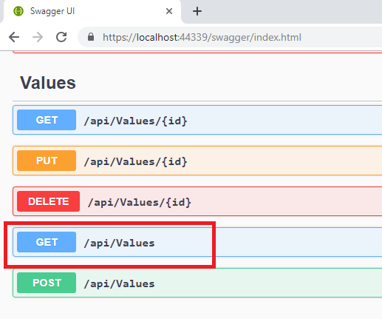
It opens a panel which has ‘Try it out’ button. Click that and Click ‘Execute’ button.
- Use POSTMAN tool, to point to the local Web API that was created with Employee controller. Test the GET action method using POSTMAN.
Verify the output if the List of employees are listed in the ‘Body’ part of the GET window on POSTMAN tool.
Verify the Status on the right side of the output pane on POSTMAN tool.
- Modify the Controller name in the Route attribute of the Employee controller to ‘Emp’ and check its access thru POSTMAN

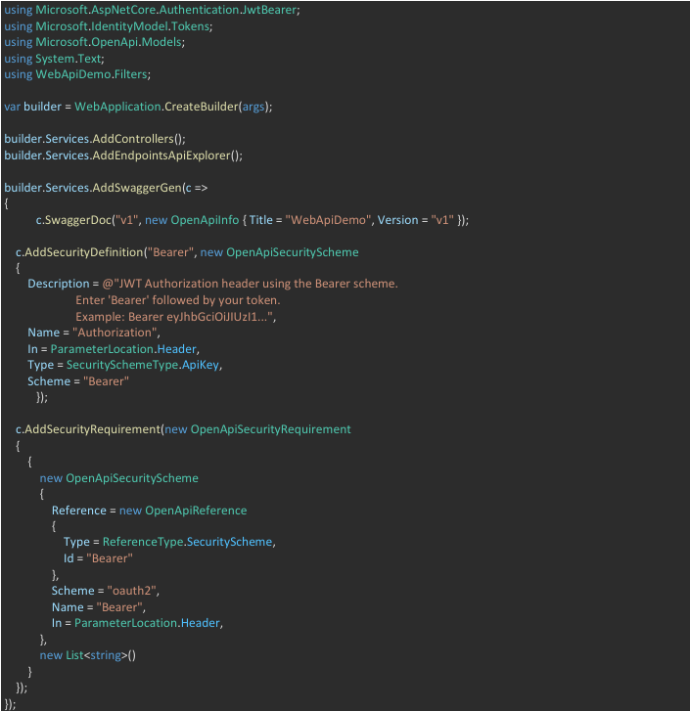

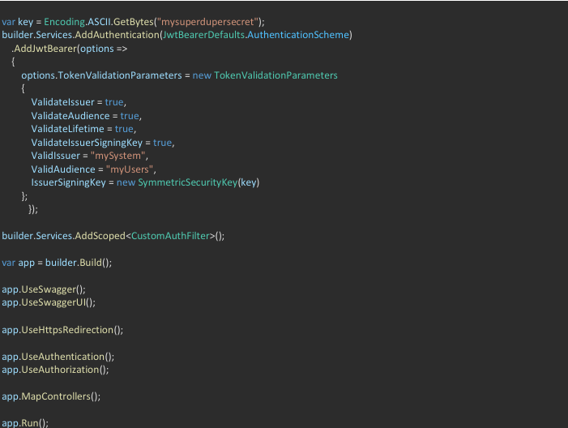
Output:
